 CHEMICAL ENGINEERING TRANSACTIONS  VOL. , 2023 | A publication of  
The Italian Association
of Chemical Engineering
Online at www.cetjournal.it

Guest Editor: Sauro Pierucci
Copyright © 2023, AIDIC Servizi S.r.l.
ISBN 978-88-95608-98-3; ISSN 2283-9216

Feasibility study of a soft sensor predicting the atmosphere composition inside a flammable liquid storage tank
Gabriele Baldissone ª*, Micaela Demichela ª, Davide Fissore ª
ª Politecnico di Torino, Corso Duca degli Abruzzi 24 Torino Italy
^{b}Affiliation and Address, no email [Style: CET Address]
corresponding.author@domain.com [Style: CET Email]
Often process plants include the storage of flammable liquids. Storage is generally considered a low-risk part of the plant, even if it can be involved in major accidents.
To guarantee tanks safety, the blanketing is usually adopted; despite it is a technique widely used in industry. In blanketing the atmosphere inside the tank is kept far from the flammability conditions thanks to the presence of an inert gas, usually nitrogen. PSVs are installed on the tank to avoid damage from critical pressure deviations. In the case of low pressure, the PSV allows air (or other gas) to enter. In this situation, the entry of air can bring the atmosphere in the tank in flammability conditions.
To keep the tank safe even when the PSV is open, it is necessary to know the composition of the vapor phase inside the tank. As an alternative to the direct monitoring of the composition of the vapor phase, a soft sensor can be adopted.
A soft sensor allows to obtain an indirect measurement of a variable from the measurement of related variables, through a mathematical model. In the specific case, by measuring the inlet and outlet flow rates and the liquid level, an estimate of the composition of the atmosphere inside the tank is obtained.
This paper presents a feasibility test of a soft sensor to estimate the composition of the vapor phase of a storage tank of liquid methanol. To develop the soft sensor, a dynamic model of the tank operation is used.

  - Introduction

In the process industry is the storage of flammable liquids is widely diffuse and is usually considered a low risk activities as the chemicals are not manipulated and are contained under controlled conditions. But at the same time, given the large quantities of material potentially stored, in the event of an accident the consequences can be very serious. In fact storage tanks have been involved in a large number of major accidents (Markatos et al., 2009, Wang et al., 2013 Chang and Lin, 2006).
In order to store flammable liquid them in safe conditions blanketing is often adopted as a prevention mean. Blanketing is a widely used in the industry but scarcely covered in the literature (Crow and Louvar, 2002, De Paola and Messina, 1984). An inert gas is supplied to the tank to prevent atmosphere from becoming flammable. Inside the tank the pressure is kept under control by a balance valve which, in case of pressure increase (for example during the filling of the tank.) discharges part of the contained atmosphere, In the event of depressurization, for example during the tank emptying and in the absence of inert gas flow, the same valve allows the air to enter the tank in order to re-establish the internal pressure. The balance valve has thus a behavior comparable to a PSV. In case the air inlet is prolonged, the atmosphere inside the tank can become flammable. In these cases, to operate safely, it is necessary to know the internal composition of the tank. An alternative to direct composition measurement that should require the installation of equipment suitable for potential flammable atmosphere is the development of a soft sensor that estimates this composition from the measurement of other variables.
Direct measurement of the concentration inside the tank provides point data. Given the size of the tanks, the point measurement of the composition of the inside composition atmosphere may be of little significance to the composition in other points which can reach dangerous compositions. At the moment, the soft sensor presented in this article provides an estimate of the average composition of the atmosphere inside the tank. The data obtained by the soft sensor is more reliable than the data obtained with point measurements as the soft sensor results is less susceptible to local conditions. In order to obtain a better result in the future evolutions of the soft sensor, this will return the composition in different positions.
A soft sensor, starting from the measurement of a sets of variables, allows to estimate another unmeasuredf variable. The soft sensor uses a mathematical model (Fortuna et al., 2007), in this case a neural network.
The neural network needs a data set for training. To identify the parameters characterizing the network. The resulting network is developed and tested on a case

  - Material and methods

    - Dynamic model

In modern safety management, the use of dynamic modeling of the equipment is proposed in different cases, such as: Baldissone et al. (2017a) for safe management of changes, in Martinetti et al (2017) for maintenance management or Baldissone et al. (2017b) for cost-benefit management.
A dynamic model of the tank is used for the development of the soft sensor, according to Figure 1. In the modeling of the tank an isothermal behavior is assumed together with a perfect mixing on the internal atmosphere. The dynamic model is based on mass balances. With the global mass balances Eq. (1) it is possible to obtain the liquid level (l) and the pressure (P) inside the tank.

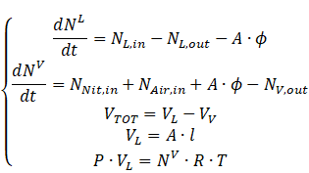 | (1)

Figure 1: Tank scheme
where N_{L} is the number of moles of liquid in the tank, N_{L,in} is the flow rate of liquid methanol entering the tank, N^{L,out} is the flow rate of liquid methanol leaving the tank, A is the tank area, Φ is mass transfer rate between the liquid and the gas phase. N_{V} is the number of moles of gas in the tank, N_{Nit,in} is the flow rate of nitrogen entering the tank, N_{Air,in} is the flow rate of air entering the tank, N_{V,out} is flow rate of gas leaving the tank. . V_{TOT} is the tank volume, V_{L} is the liquid volume and V_{V} is the gas volume, R the ideal gas constant and T temperature.
From the mass balances of the individual components Eq. (2), the composition of the atmosphere contained in the tank is obtained.

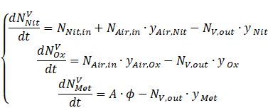 | (2)

Where N_{VNit} is the number of moles of nitrogen in the gas phase, N_{VOx} is the number of moles of oxygen in the gas phase and N_{VMet} is the number of moles of methanol in the gas phase. Instead y_{Air,Nit} is the nitrogen concentration in the air, y_{Air,Ox} is the oxygen concentration in the air, y_{Nit} is the nitrogen concentration in the tank gas phase, y_{Ox} is the oxygen concentration in the tank gas phase and y_{Met} is the methanol concentration in the tank gas phase.
The flow rate of vapors originating from the free surface of the liquid is estimated with Eq. (3):

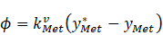 | (3)

Where k_{VMet} is the methanol transfer coefficient between liquid and gas phase, y*_{Met} is the equilibrium concentration of methanol in the gas phase. The methanol transfer coefficient is evaluate according to Crowl and Louvar (2002).
The flow rate of output gas and of the input air has been estimated in accordance with the API 12000: 1998 standard dedicate to the design of pressure relief system.
The model developed is used to produce the data for the training phase and the data set used to confirm the prediction

    - Neural networks

For the soft sensor, neural networks are used since they are able to reproduce non-linear behaviors and require limited calculation times. Neural networks are characterized by a series of parameters (Brett 2015 T), including the number of layers and the number of nodes in the various layers and by their architecture (Haykin, 2009). A generic structure is shown in Figure 2 simple operations are performed, represented in Eq. (4).

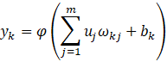 | (3)

Where u_{i} is the input signal, bk is the bias, ω_{kj} is the synaptic weight, φ is the activation function and y_{k} the neuron output.

During the training of the neural network the optimal values of weights and biases of the various nodes are found to reduce the modelling errors of the training data set.

  - Results

The soft sensor are tested in a case study of a tank containing methanol, of a capacity of 100m3. Tank’s height is approx. 5.3 m and 245 kg/h of methanol are continuously removed from the tank to be used in the process downstream. With the nitrogen supply, the pressure inside the tank is kept constant. Due to process consumption, when the methanol level falls below 30%, the tank is re-filled to 80% of its capacity. The PSV is set to intervene at an overpressure of 7 kPa and a depressurization of 1 kPa.
With the dynamic model described above, a dataset used to training neural networks and one used for soft sensor testing were produced.
For the development of the soft sensor, the configuration shown in the Figure 2 was used. Two neural networks are used, one for the estimation of the methanol concentration and one for the estimation of the nitrogen concentration. Neural networks use methanol and nitrogen inlet flow rates, methanol exhaust flow rate, and liquid level as input data.

y_{Met}
y_{Nit}
Soft sensor
Neural network 1
Neural network 2
N_{L,in}
N_{L,out}
N_{Nit,in}
Liquid level

Figure 2: Soft sensor structure

A data set of 125,000 data was used to train the neural network, where the methanol discharge rate varying between 120 and 370 kg/h and the nitrogen flow rate between 0 and about 0.5 kg/h, Figure 3.
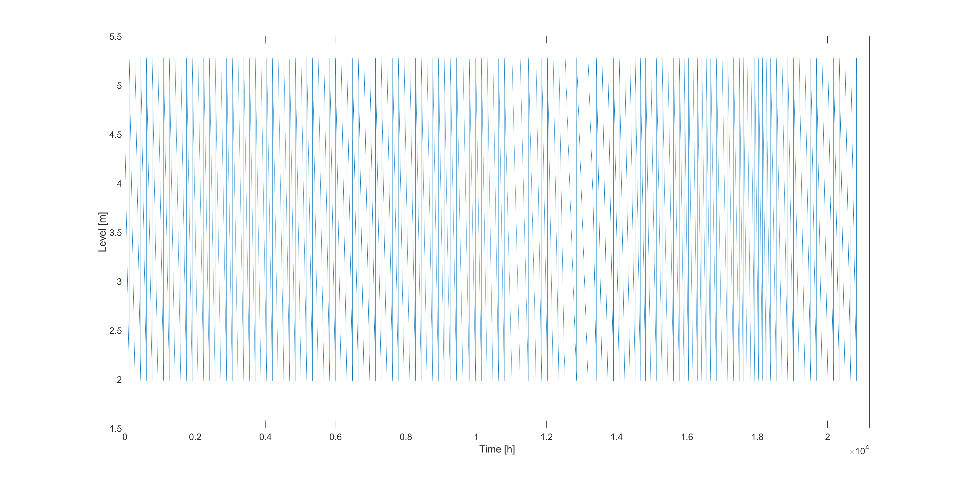
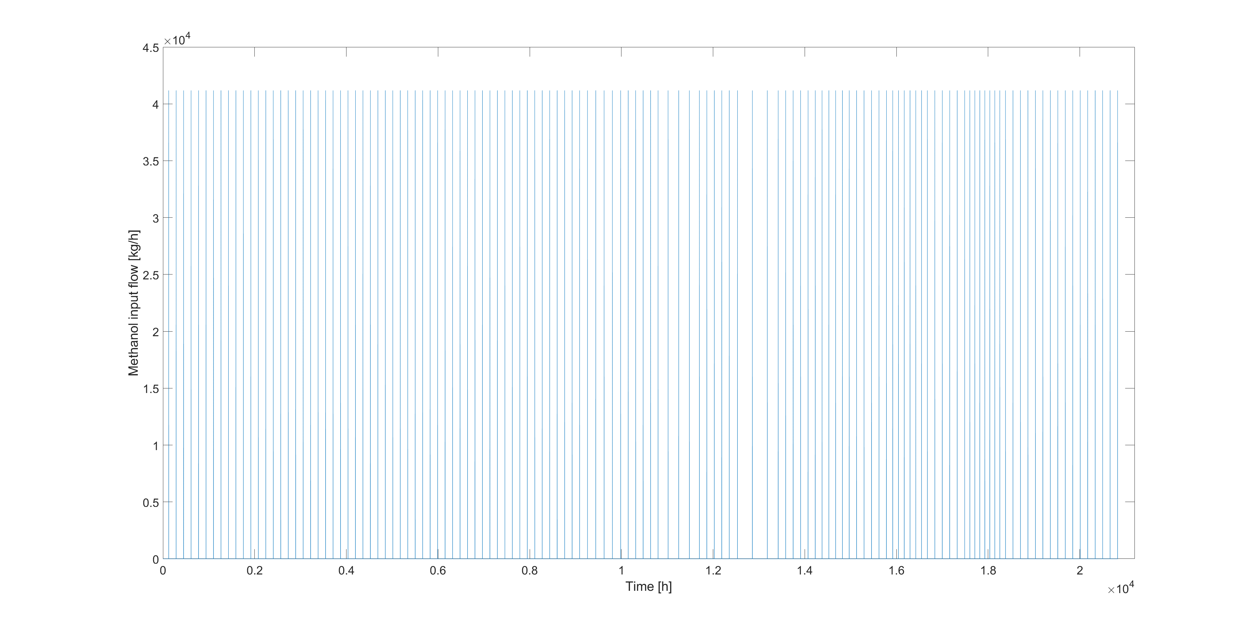
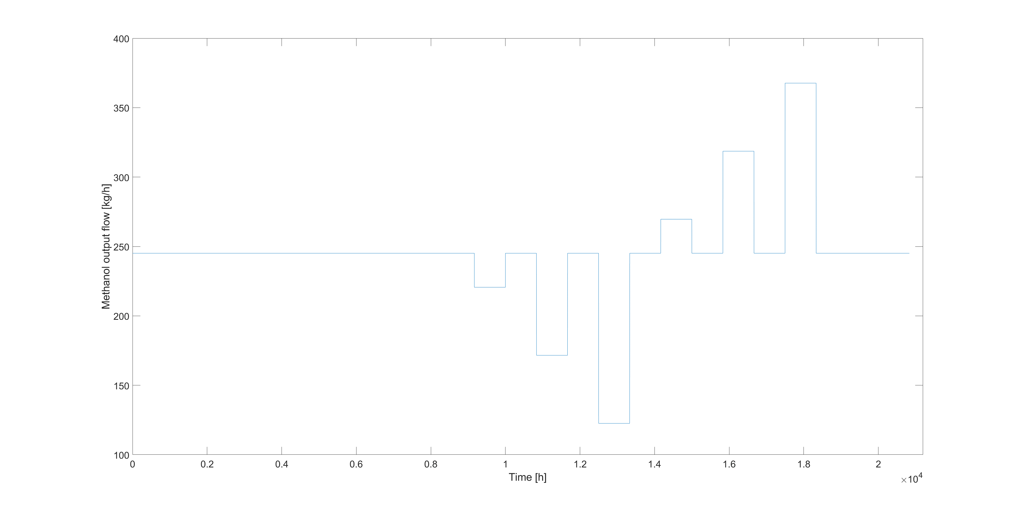
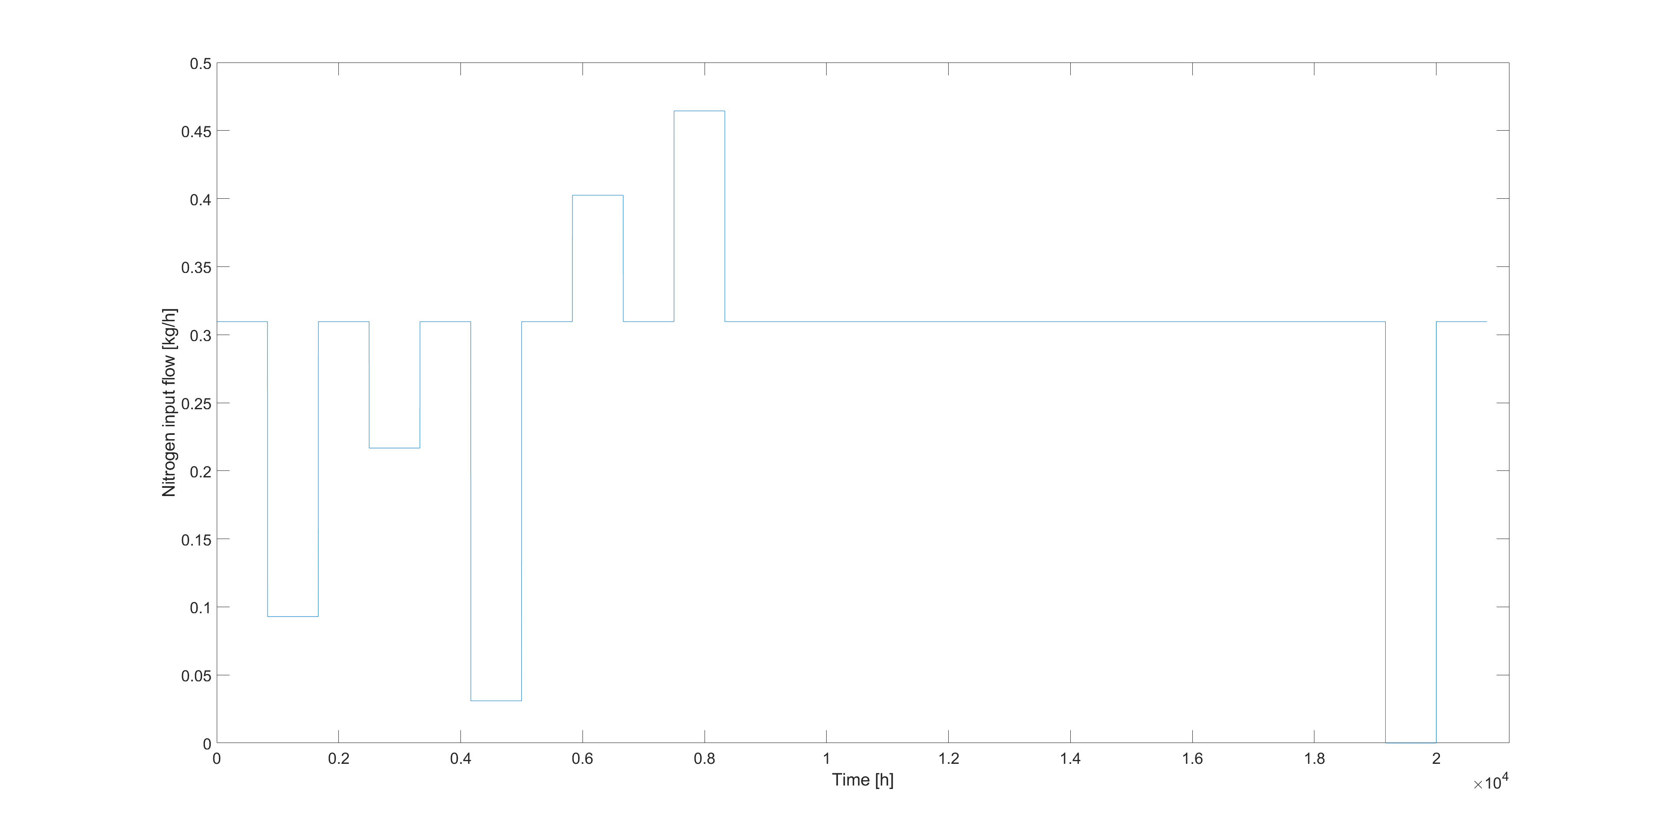
(a)
(b)
(c)
(d)

Figure 3: Data set used for the neural network training (a) methanol input flow; (b) level; (c) Nitrogen input flow; (d) methanol output flow

Figure 4 shows the concentration trends in the tank obtained from the dynamic model and from the soft sensor, in the case of the training data set. As illustrated in figure 4, the soft sensor faithfully reproduces the trend of the composition of the atmosphere inside the tank.
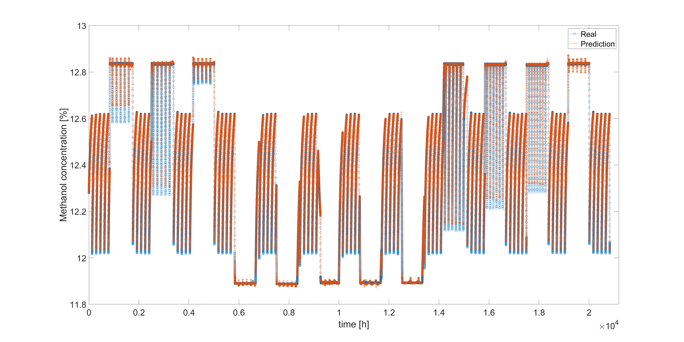
(a)
(b)

Figure 4: Atmosphere composition obtained by the dynamic model and the soft sensor with the training data set (a) nitrogen concentration.

Normal operational condition of the tank were initially used to test the soft sensor. The figure 5 shows that also in this case the soft sensor accurately reproduces the trend of the internal composition, a maximum prediction error of about 0,1883% for the nitrogen concentration and 0,0327%for the methanol vapor concentration.
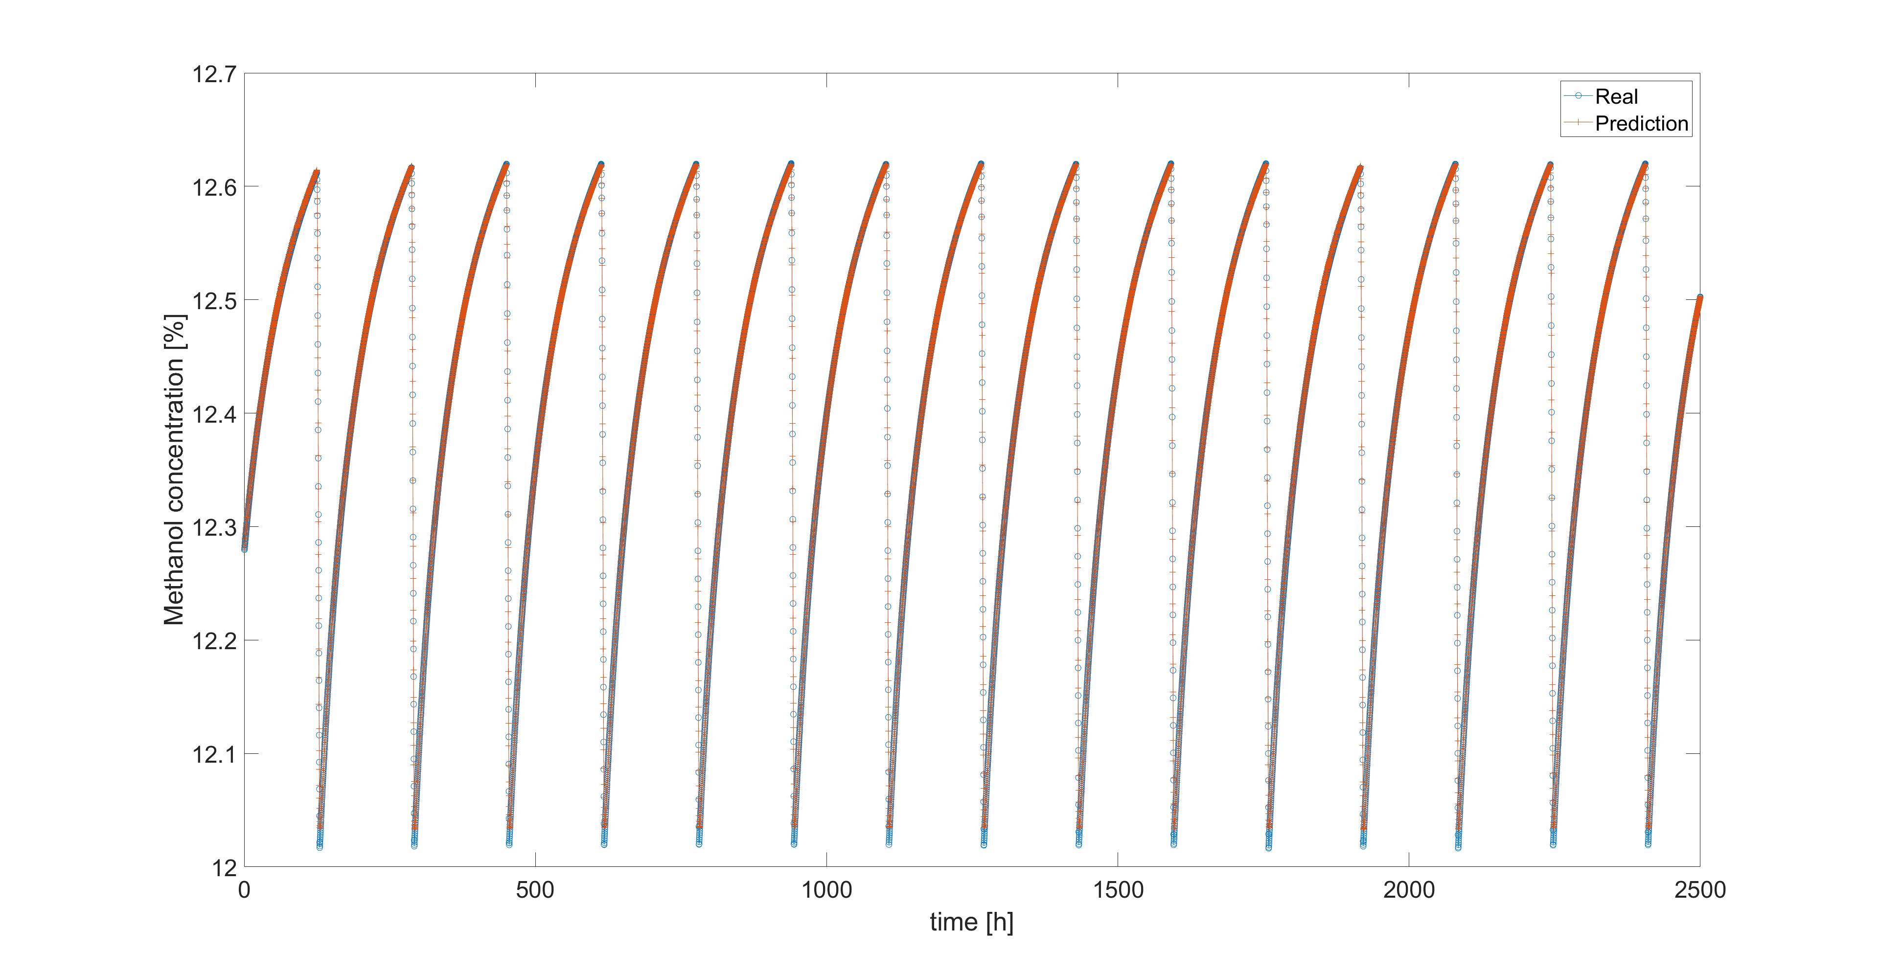
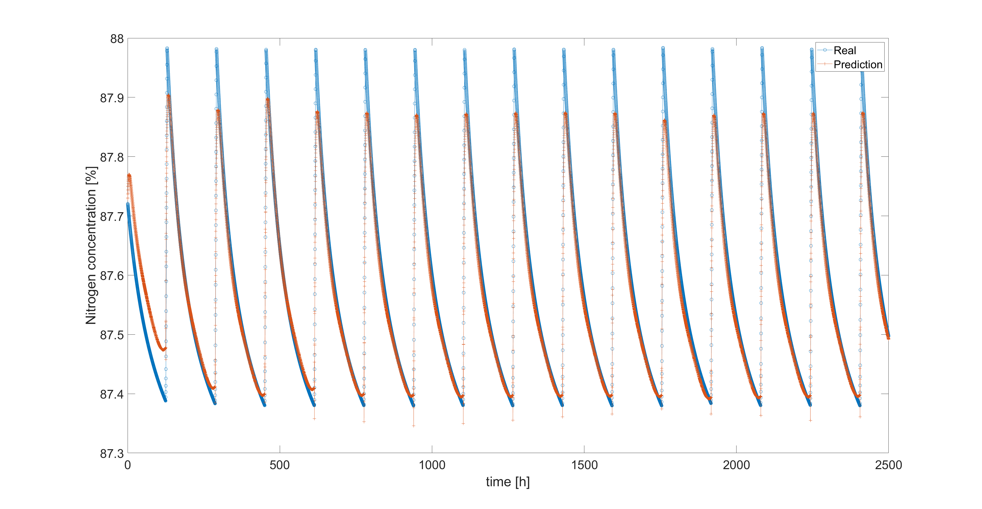
(a)
(b)
Figure 5: Atmosphere composition obtained by the dynamic model and the soft sensor during the normal operation (a) nitrogen concentration.

As an example, another data set is shown, which describes the reduction of the nitrogen flow rate to about 0.05kg/h, then the flow rate is restored to the normal value. This case is presented as particularly critical, since the entry of air into the tank makes the internal atmosphere flammable. Also in this case the soft sensor faithfully reproduces the trend of the composition inside the tank (Figure 6). With maximum predictive error for the nitrogen concentration of 0,9202% and of 0,0785% for the methanol vapor concentration.
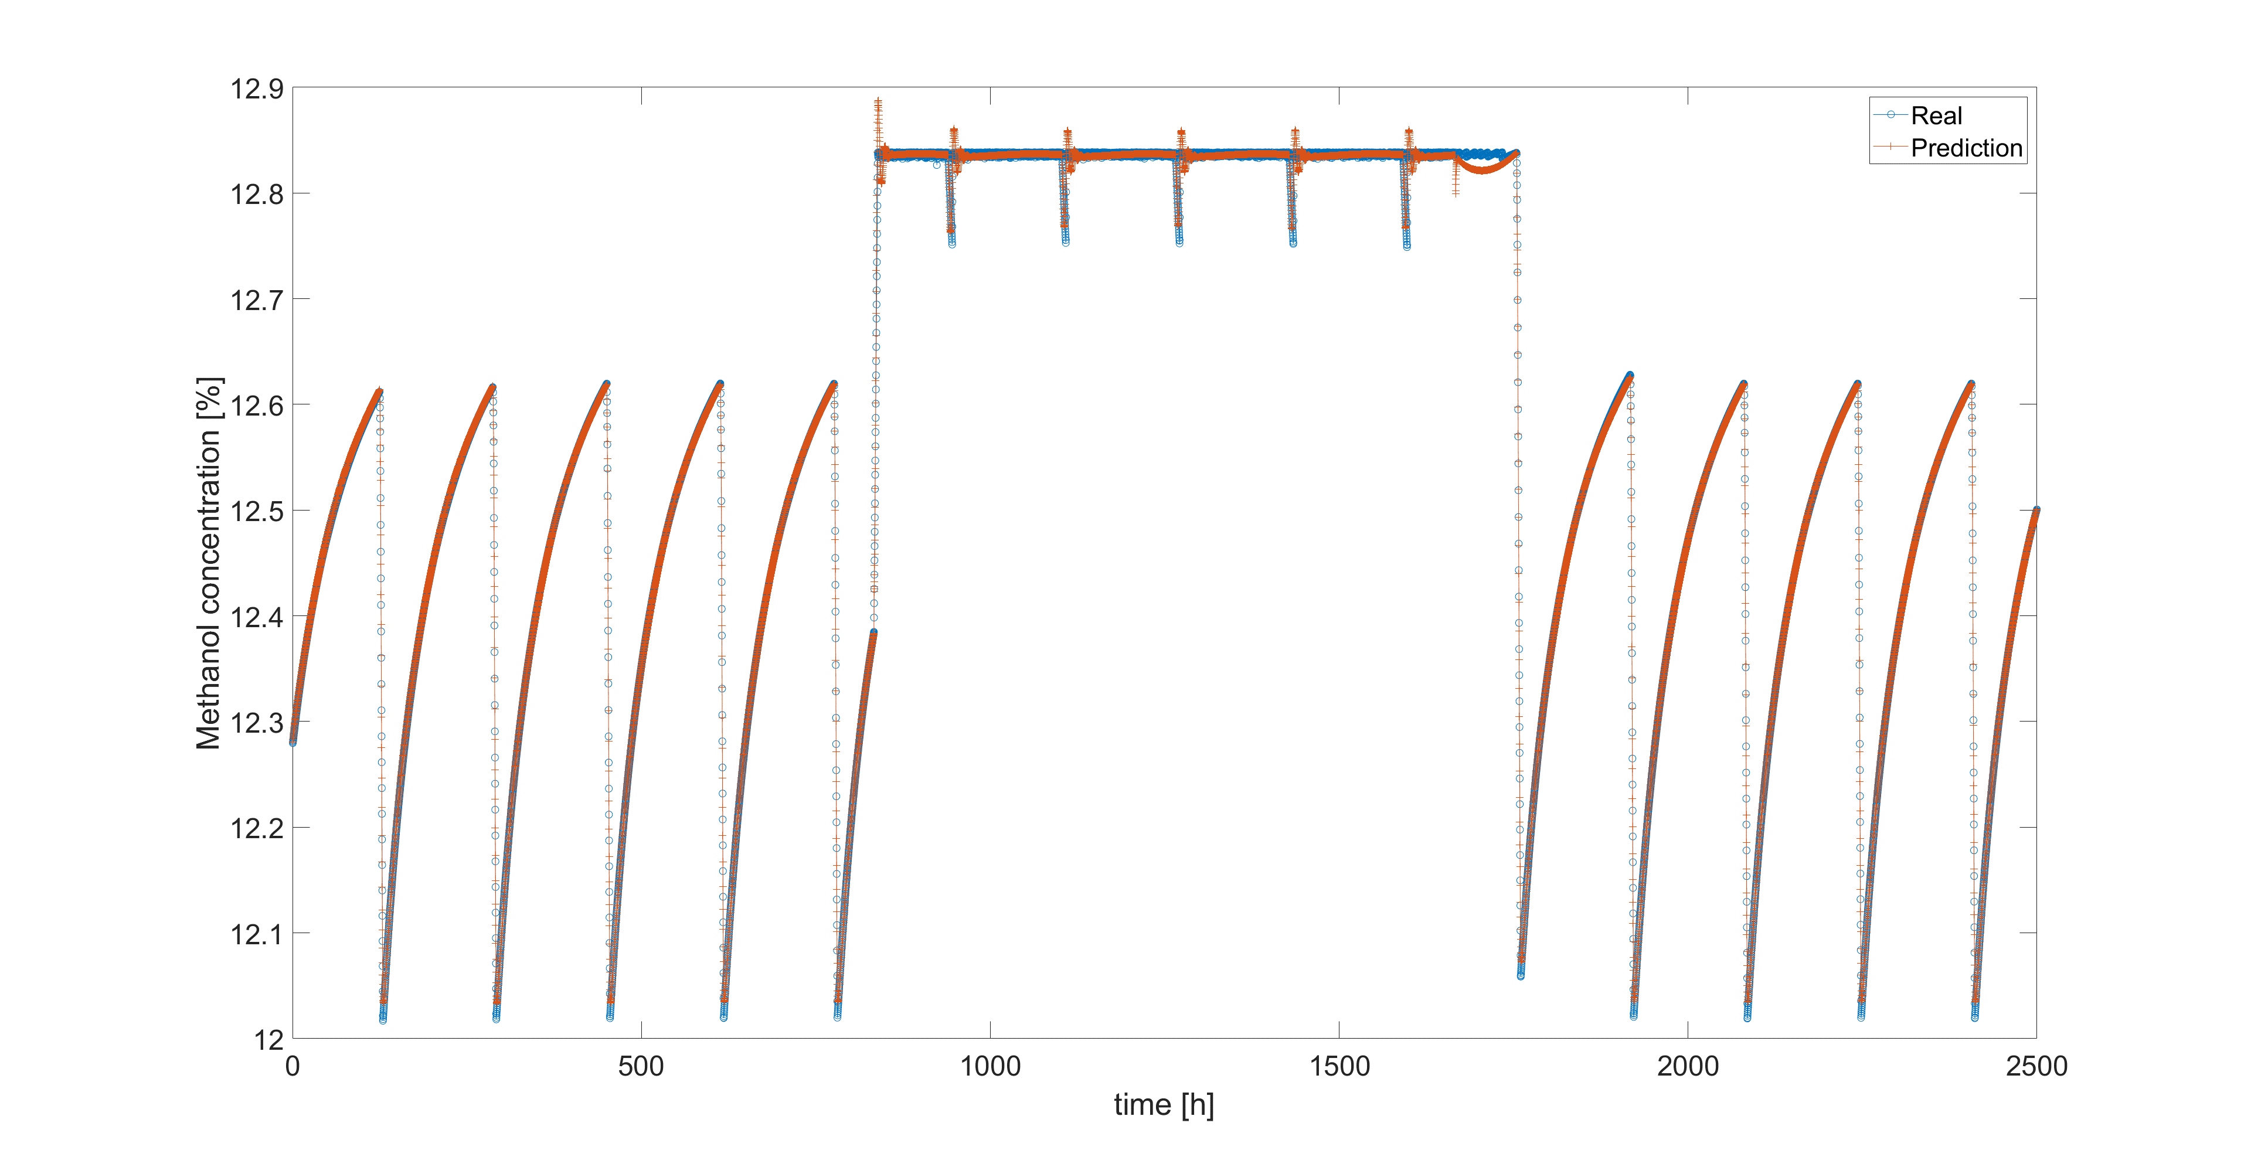
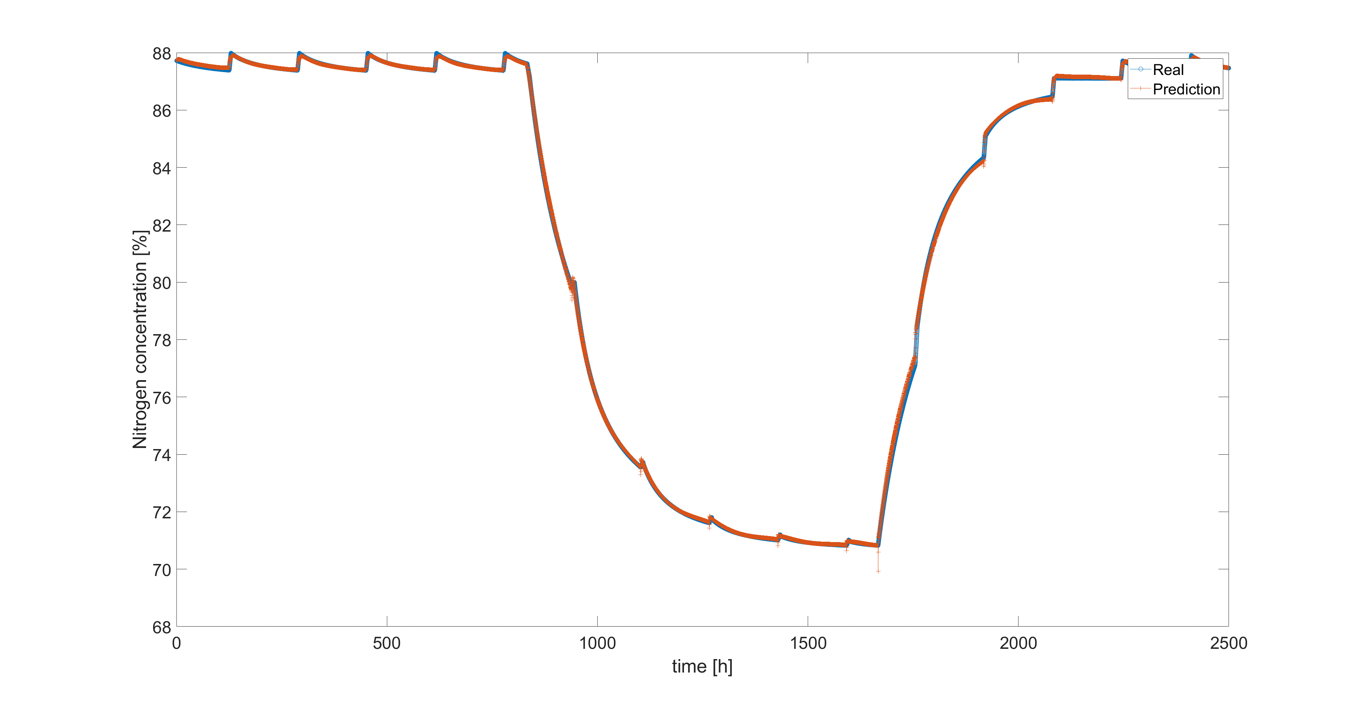
(a)
(b)
Figure 6: Atmosphere composition obtained by the dynamic model and the soft sensor n the test case (a) nitrogen concentration.
  - Conclusion

Large quantities of flammable liquids are stored in process plants. To store them safely the blanketing is done. In these cases the tanks are equipped with balance valves, usually managed as PSV. In the event of overpressure, these valves allow part of the atmosphere inside the tank to exit. Instead, in the case of depressurization it allows the entry of air.
But in this case the entry of air can make the atmosphere inside the tank flammable. If air enters, it is necessary to monitor the composition of the atmosphere inside the tank. Monitoring can be done through directly composition measurement, but the measurement can only be done point-wise. But the measurement can only give local results which are not necessarily representative of the most critical conditions of the tank.
In this article an alternative to the direct measurement of the composition inside the tank is presented through the development of a soft sensor. The soft sensor presented in this article returns the average composition of the internal atmosphere. In future evolutions of the soft sensor, it will be able to provide the differentiated composition of the various sections of the internal atmosphere in order to identify the most critical conditions.
The soft sensor presented in this paper uses two neural networks which, starting from the liquid inlet and outlet flow rates, the nitrogen inlet flow rate and the liquid level in the tank, returning the concentration of flammable vapours and the nitrogen concentration.
A dynamic model of tank operation was used to develop the soft sensor. With the dynamic model, a data set was produced which is used for training neural networks. The dynamic model is also used to test the quality of the results obtained from the soft sensor. As previously illustrated, the prediction of the soft sensor turns out to have contained errors.

References

Baldissone G., Demichela M., Camuncoli G., Comberti L., 2017a, Formaldehyde production plant modification: Risk based decision making, Chemical Engineering Transactions, 57, 703-708
Baldissone G., Demichela M., Fissore D., 2017b, Lean VOC-air mixtures catalytic treatment: Cost-benefit analysis of competing technologies, Environments, 4(3) 1-18.
Brett, L. 2015, Black Box Methods - Neural Networks and Support Vector Machines, Chapter In: Discover How to Build Machine Learning Algorithms, Prepare Data, and Dig Deep into Data Prediction Techniques with R, Packt Publishing, Birmingham, UK, 219–257.
Chang J. I., Lin C. C., 2006, A study of storage tank accidents, Journal of Loss Prevention in the Process Industries, 19 51–59
Crowl D. A., Louvar J. F., 2002, Chemical Process Safety: Fundamentals with Applications, Prentice Hall, Upper Sandle River.
De Paola T. J., Messina C. A., 1984, Nitrogen Blanketing, Plant operations progress, 3, 203–212.
Fortuna L., Graziani S., Tizzo A., Xibilia M. G., 2007, Soft Sensors for Monitoring and Control of Industrial Processes, Springer, London.
Haykin, S., 2009, Neural networks and learning Machine. Third Edit. Prentice Hall, Upper Sandle River.
Markatos N. C., Christolis C., Argyropoulos C. D., 2009, Mathematical modeling of toxic pollutants dispersion from large tank fires and assessment of acute effects for fire fighters, International Journal of Heat and Mass Transfer, . 52, 4021–4030.
Martinetti, A., Braaksma, A. J. J., van Dongen, L. A. M. 2017, Beyond RAMS Design: Towards an Integral Asset and Process Approach. In L. Redding, R. Roy, A. Shaw (Ed.), Advances in Through-life Engineering Services, Springer, 417-428
Wang D., Zhang P., Chen L., 2013, Fuzzy fault tree analysis for fire and explosion of crude oil tanks, Journal of Loss Prevention in the Process Industries, 26, 1390–1398.

